Experiment No – 05

Title - Write a program to list prime numbers from 1 to 500 using for statement.

Theory-

C supports nesting of loops in C. A nested loop is a loop within a loop, an inner loop within the body of an outer one. How this works is that the first pass of the outer loop triggers the inner loop, which executes to completion. Then the second pass of the outer loop triggers the inner loop again. This repeats until the outer loop finishes.

Any number of loops can be defined inside another loop, i.e., there is no restriction for defining any number of loops. The nesting level can be defined at n times. You can define any type of loop inside another loop; for example, you can define 'while' loop inside a 'for' loop.

Syntax of Nested loop
Outer_loop
{
Inner_loop
{
// inner loop statements.
}
// outer loop statements.
}
Outer_loop and Inner_loop are the valid loops that can be a 'for' loop, 'while' loop or 'do-while' loop.

Nested for loop-

The nested for loop means any type of loop which is defined inside the 'for' loop.
for (initialization; condition; update)
{
for(initialization; condition; update)
{
// inner loop statements.
}
// outer loop statements.
}

Nested while loop-
while(condition)
{
while(condition)
{
// inner loop statements.
}
// outer loop statements.
}

Flow chart of nested while loop-

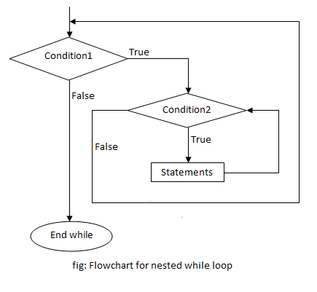
Break Statement:
The break statement ends the loop immediately when it is encountered. Its syntax is:
break;
The break statement is almost always used with if...else statement inside the loop.

How break statement works?
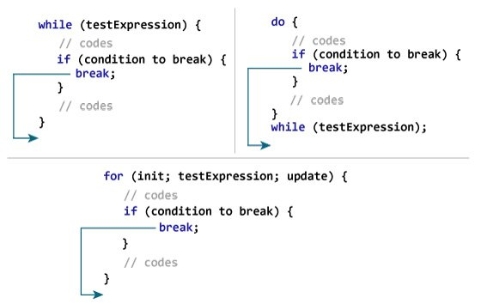Working of break in C

Continue Statement:
The continue statement skips the current iteration of the loop and continues with the next iteration. Its syntax is:
continue;
The continue statement is almost always used with the if...else statement.

How continue statement works?
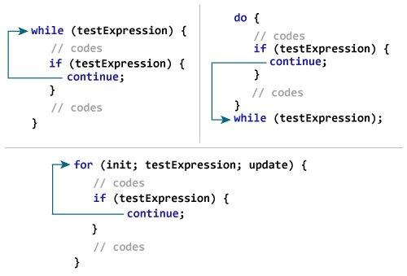
Working of Continue in C
Both, break and continue, statements are of the same type, and they allow a user to change or alter the flow of a programme. They are, however, distinct. The main difference between the break and continue statements in C is that the break statement causes the innermost switch or enclosing loop to exit immediately. The continue statement, on the other hand, starts the next iteration of the while, for, or do loop. The continue statement immediately takes control of the test condition in while and do loops. In the case of a for loop, it also takes control of the loop's increment step. The continue statement can only be used on loops and not on switches.
Exercise-
- Write a program to display multiplication table of numbers from 1 to 10.
- Write a program to list Armstrong numbers from 1 to 500.
- Write a program to list perfect numbers from 1 to 500. (A perfect number is a number that is equal to the sum of its proper divisors. For example, the divisors of 6 are 1, 2 and 3. The sum of the proper divisors of 6 is 1 + 2 + 3 = 6, which is a perfect number.)

